PROJECT AND TEAM INFORMATION

Project Title
Real-Time System Resource Monitor using Python and Tkinter

Student / Team Information
Team Name:  Team # | BytePulse  SE(OS)-VI-T094
Team member 1 (Team Lead) | Upadhyay,Hrishabh-22021364  hrishiofficial01@gmail.com  
Team member 2 | Adhikari,Surabhi-220221292    72005saumyasurabhi@gmail.com
Team member 3 | Verma,Prakshi-220221700  p60078590@gmail.com  
Team member 4 | Agarwal,Kritika-220221012  agarwalsonu793@gmail.com  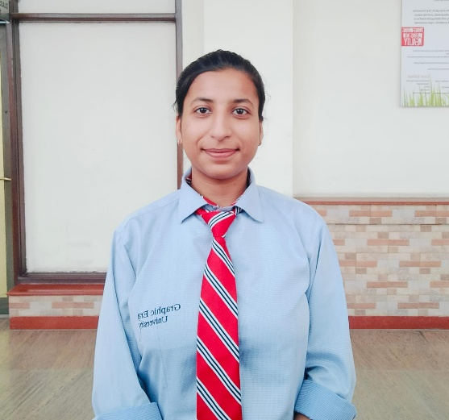

PROPOSAL DESCRIPTION

Motivation

Modern operating systems manage multiple processes and system resources (CPU, RAM, disk, and network) simultaneously. However, native system monitors are either too basic or too complex. This project aims to develop an intuitive, real-time, and visually appealing system monitor with the added functionality of process termination and resource visualization, all in a compact and customizable GUI using Python.
Unlike platform-specific tools, this cross-platform solution provides flexibility and personalization through theme switching, metric selection, and lightweight performance.
It is especially useful for developers, testers, and system administrators looking to integrate monitoring into their workflows or automation scripts seamlessly.

State of the Art / Current solution

State of the Art / Current Solution
Modern OS tools like Windows Task Manager, Linux htop, and macOS Activity Monitor offer robust system monitoring features. However, they have notable limitations:
Limited Customizability: Users can't easily personalize metrics, themes, or refresh rates [2].
Platform Dependence: These tools are OS-specific and not consistently available across platforms [1].
Lack of Integration: They don't integrate well with Python scripts or automation workflows [1][4].
No Unified Lightweight Tool: There's a lack of an open-source, lightweight, cross-platform GUI that combines monitoring and process management in Python [1][2][3]

Our Solution
We propose a Python-based, cross-platform system monitor with real-time visualizations and process control [1][2][3].
Key Features:
- Real-Time Monitoring: Live graphs for CPU, RAM, Disk, and Network usage [3]
- Custom Visualizations: Users can choose metrics, switch themes, and adjust layout [2]
- Process Management: View and terminate processes with real-time resource stats [1]
- Python & Open Source: Built using Tkinter, psutil, and matplotlib for easy modification [1][2][3]
- Lightweight: Efficient use of resources with rolling data windows to prevent memory issues [1]
- Automation-Ready: Easily extendable for custom alerts or automation based on usage thresholds [4]

Project Goals and Milestones

Goal / Milestone | Status / Timeline
Initial GUI layout with Tkinter | Completed
Real-time CPU, Memory, Disk, and Network stats | Completed
Graph switching via dropdown menu | Completed
Live updating plots using matplotlib backend | Completed
Process viewer with PID, CPU %, Memory % | Completed
Process termination feature | Completed
Optimize resource usage & refresh intervals | In progress
Packaging into executable (.exe/.app) | Future scope

Project Approach

- Frontend: GUI designed with Tkinter using modern styling (ttk themes)
- Backend: psutil for system resource and process tracking
- Plotting: Real-time dynamic graphs rendered using matplotlib
- Refresh Loop: Timed updates via root.after() without blocking GUI
- Data Management: Rolling time window to prevent memory bloat
- Interactivity: Drop-down to switch plots; TreeView to show process list
- Safety: Catch exceptions during process access (e.g., access denied, process gone)

System Architecture (High Level Diagram)

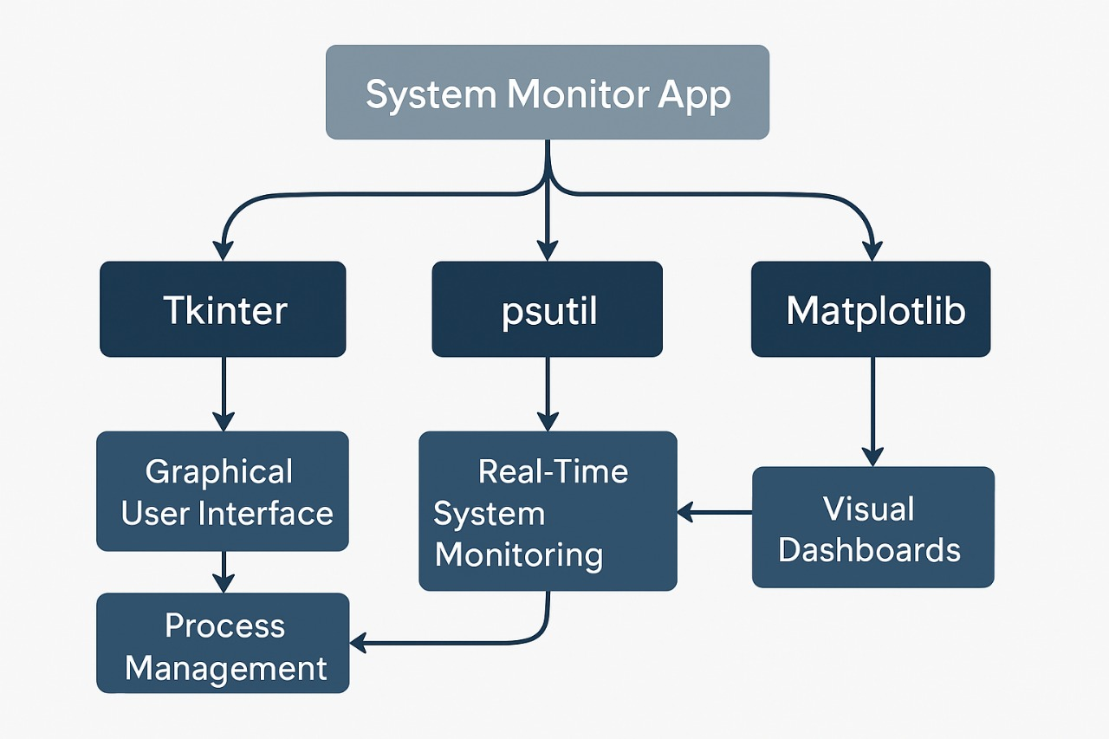

Project Outcome / Deliverables (1 pts)

A fully functional Python application that:

- Monitors CPU, Memory, Disk, and Network usage in real time
- Plots data dynamically using matplotlib in a Tkinter window
- Displays active process list with sorting columns
- Enables safe process termination from the GUI
- Shows current metrics as textual labels
- Is visually consistent with a dark theme

Assumptions
- App will be used on desktop OS (Windows/Linux) only.

- User has appropriate privileges to view and terminate processes.

- Internet is not required for operation.

- App will be tested on machines with Python 3.7+, psutil, matplotlib, and tkinter available.

References

- psutil documentation – https://psutil.readthedocs.io

- Tkinter official documentation – https://docs.python.org/3/library/tkinter.html

- matplotlib embedding in Tkinter – https://matplotlib.org/stable/users/explain/interactive.html

- Stack Overflow – Helpful discussions and code snippets for TreeView, GUI optimization, and styling
- https://stackoverflow.com/questions/tagged/tkinter
- https://stackoverflow.com/questions/tagged/psutil

